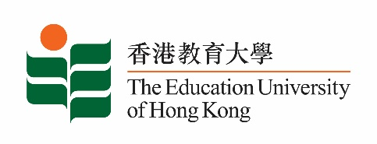
致： 传媒机构采访主任 (共 2页) 5 November 2021
To : News Editors (total: 2 pages)

香港教育大学2021年11月8日至21日可供采访之活动一览
The Education University of Hong Kong (EdUHK) Events Calendar for 8 to 21 November 2021
本校诚邀 贵机构派员采访下列活动。传媒查询，请联络教大传讯处（电话：2948 6050）。
You are cordially invited to cover the events below. For media enquiries, please contact the Communications Office at 2948 6050.

因应2019冠状病毒疫情，以下活动或有人数限制，传媒请预先向主办部门登记。
In light of the COVID-19 pandemic, there may be restrictions on the number of participants for the following event(s). Please contact the respective organiser(s) / department(s) for prior registration.

- 教大大埔校园 （新界大埔露屏路十号） / EdUHK Tai Po Campus (10 Lo Ping Road, Tai Po, New Territories)

日期  Date | 时间  Time | 活动  Event | 地点  Venue | 主办部门及公众查询  Organiser &  Public Enquiry | 备注  Remarks
2021-11-13 | 2:30 pm –  4:30 pm | 2021年文学月会 / 香港文学专题讲座︰「妙笔呈锦绣──香港粤剧剧本共赏」系列：优秀剧本的特征：兼论粤剧《胡不归》与戏剧教育  Monthly Literary Talk 2021 / Subject Talk on Hong Kong Literature: "Appreciating Cantonese Opera: Scripts by Hong Kong Playwrights" Series: The Characteristics of Outstanding Libretti of Cantonese Opera: Application in Theatre Education  讲者 / Speaker:  何文汇教授  Professor Ho Man-wui, Richard  梁宝华教授  Professor Leung Bo-wah | 香港中央图书馆  （地下演讲厅）  Hong Kong Central Library  (Lecture Theatre, G/F) | 合办 / Co-Organiser:  康乐及文化事务署香港公共图书馆与教大粤剧传承研究中心  Hong Kong Public Libraries, Leisure and Cultural Services Department and Research Centre for Transmission of Cantonese Opera, EdUHK  查询 / Enquiries:  王先生 Mr Wong  电话 / Tel :  2948 7856 | 免费入场，名额有限，先到先得。  Seats are limited. Free admission on a first come, first served basis.  详情 / Details:  https://www.eduhk.hk/rctco/ch/news.php

